1. Retrieve Students with Their Total Credits Earned

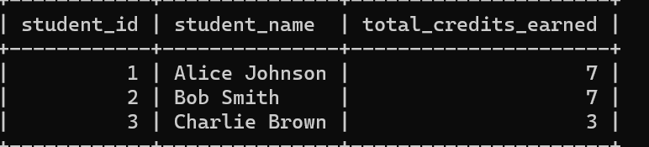

Your query:

1. Retrieve a List of Courses with the Average Grade

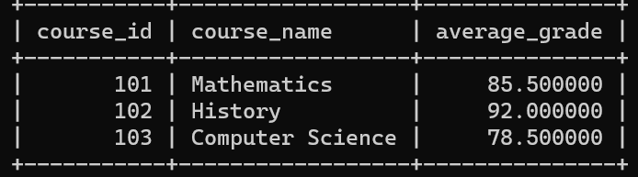

Your query:

1. Retrieve a list of students along with the courses they are enrolled in, their enrollment dates, and their grades

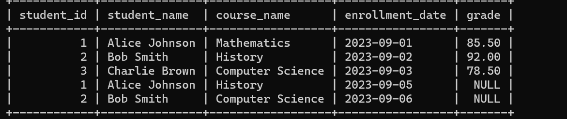

1. Retrieve Courses with the Number of Students Enrolled and Average Grade  
   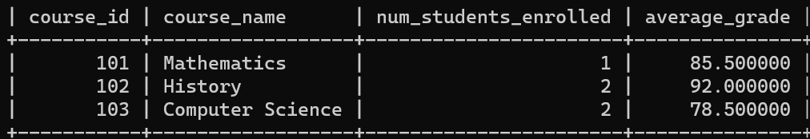

Your query:

1. Retrieve Students with Their Total Credits Earned and Average Grade  
   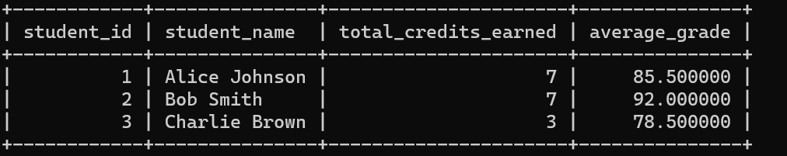

Your query:

1. Retrieve Courses with Their Students and Maximum Grade

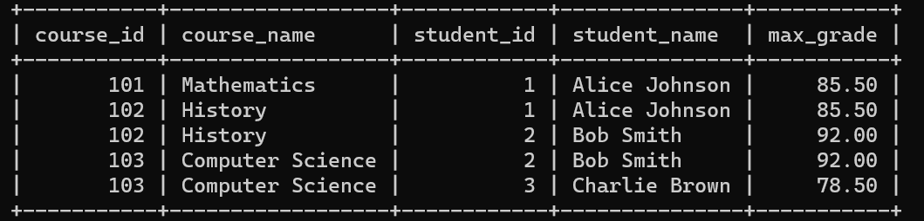

Your query:

1. Retrieve Courses with the Number of Students Enrolled and Their Average Grade

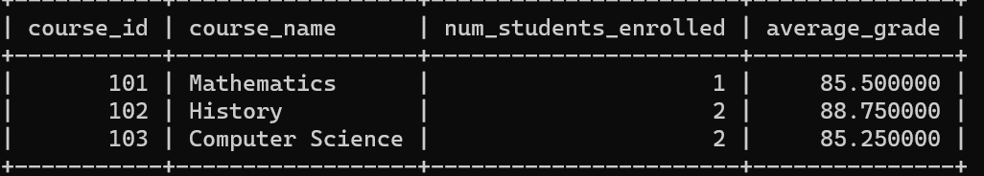

Your query:

1. Write a SQL statement to create a VIEW named “StudentInfo” to show all the students

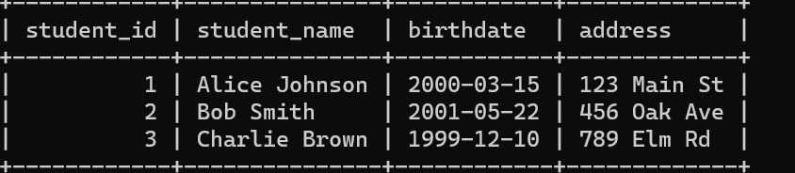

You query:

1. Write a SQL statement to create a VIEW named “StudentEnrollmentDetails” to show all detail of enroll.

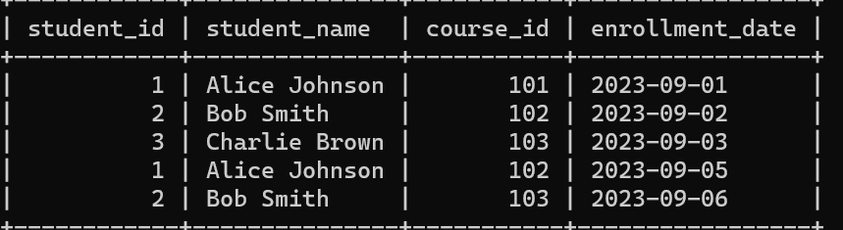

Your query:

1. Write a SQL statement to create a VIEW named “CourseEnrollmentStats” to show about courses, including the course name, the number of students enrolled, and the average grade for each course.

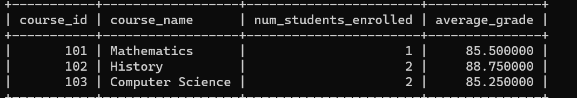

Your query:

1. Create a view to retrieve student information with enrollment statistics and average credits greater than 3(name: **StudentEnrollmentStats**)

